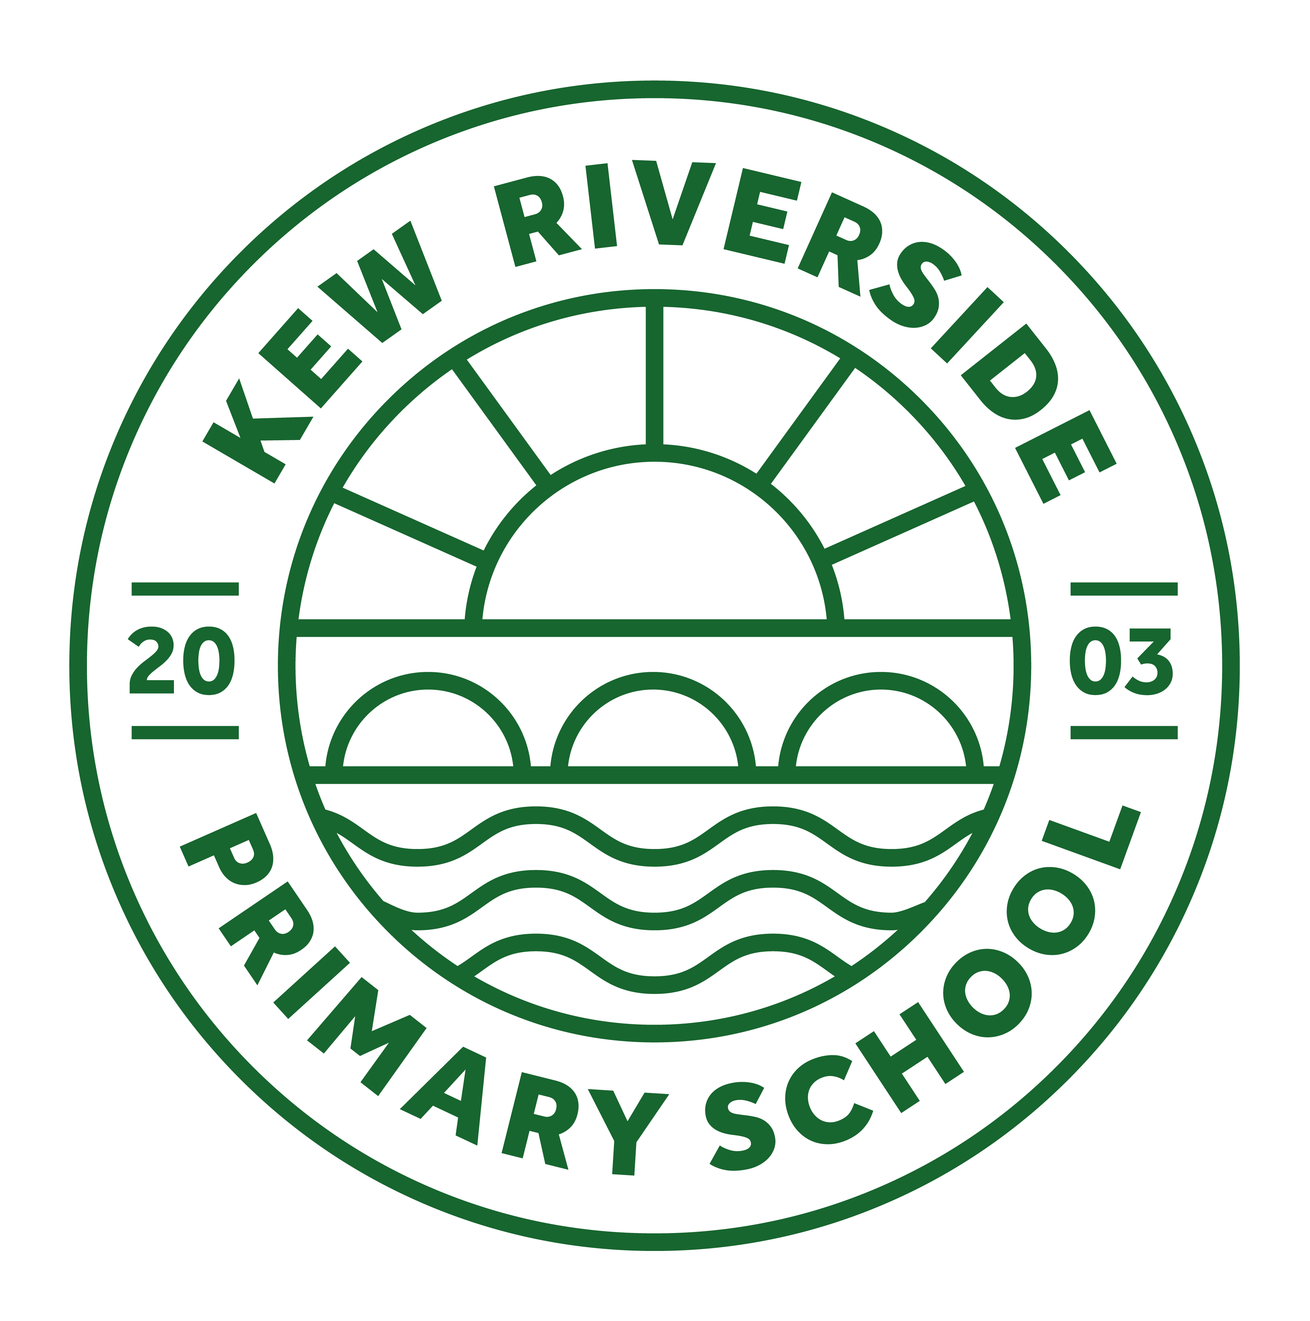

Friday 27th May 2022

**RSHE (Relationships, Sex Education and Health Education) after half term**

Dear Parent/Carer,

As you may be aware, from September 2020 the Department for Education has made Relationships and Health Education (Primary) and Relationships, Sex Education and Health Education (Secondary) compulsory in all schools. The statutory guidance can be found here: [https://www.gov.uk/government/publications/relationships-education-relationships-and-sexeducation-rse-and-health-education](https://www.gov.uk/government/publications/relationships-education-relationships-and-sex-education-rse-and-health-education)

At Kew Riverside Primary School, RSHE is currently and will continue to be taught through Personal

Social and Health Education (PSHE) lessons using the Jigsaw programme. For schools in England, the Jigsaw is fully compliant with the statutory relationships and health education guidance (2019).

**What must primary schools teach in Relationships Education, Health Education and Sex Education?**

For Primary aged children this includes curriculum content under two headings:

|  |  |
| --- | --- |
| Relationships Education | Health Education |
| Families and people who care for me  Caring Friendships  Respectful Relationships  Online Relationships  Being safe | Mental wellbeing  Internet safety and harms  Physical health and fitness  Healthy Eating  Drugs, alcohol and tobacco  Health and prevention  Basic first aid  **Changing adolescent body** |

**Sex Education**

At Kew Riverside Primary School, we define Sex Education as relating to human reproduction and intend to teach this alongside the Health Education content as part of the Jigsaw unit ‘Changing Me’.

**What will my child actually be taught about puberty and human reproduction?** Jigsaw’s ‘Changing Me’ unit is taught in the second half of the summer term, week beginning the 13th June. Each year group will be taught appropriate to their age and developmental stage, building on the previous years’ learning. Please note: at no point will a child be taught something that is inappropriate; and if a question from a child arises and the teacher feels it would be inappropriate to answer, (for example, because of its mature or explicit nature), the child will be encouraged to ask his/her parents or carers at home. The question will not be answered to the child or class if it is outside the remit of that year group’s programme.

The Changing Me Puzzle is all about coping positively with change and includes:

**Ages 3-5** Growing up: how we have changed since we were babies.

**Ages 5-6** Boys’ and girls’ bodies; correct names for body parts.

**Ages 6-7** Boys’ and girls’ bodies; body parts and respecting privacy (which parts of the body are private and why this is).

**Ages 7-8** How babies grow and how boys’ and girls’ bodies change as they grow older. Introduction to puberty and menstruation.

**Ages 8-9** Internal and external reproductive body parts. Recap about puberty and menstruation. Conception explained in simple terms.

**Ages 9-10** Puberty for boys and girls in more detail including the social and emotional aspects of becoming an adolescent. Conception explained in simple biological terms.

**Ages 10-11** Puberty for boys and girls revisited. Understanding conception to the birth of a baby. Becoming a teenager.

All lessons are taught using correct terminology, child-friendly language, diagrams and some animations to show the male and female reproductive systems.

**Does my child have to take part in RSHE?**

All schools have a statutory duty to teach pupils the aspects of Relationship Education and Health Education and pupils cannot be withdrawn from these lessons. As we have made the decision to teach Sex Education as part of the ‘Changing Me’ unit, pupils may only be withdrawn from specific lessons relating to human reproduction e.g. conception and birth. Withdrawal from these sessions must be granted by the Head or Deputy Headteacher following submission of the attached withdrawal form.

**If you have any specific queries regarding your child, or the materials used to teach RSHE please arrange to speak to their class teacher.**

Thank you for your continued support

https://lh4.googleusercontent.com/D5kxPI4H4rb6ebwh0RMcxMl3HfOo1eSN_qzjV-2EsNk39sn8Wi6xurYktKe_HuI5RRhy_6d8ZP_RN1AzmtbPAtMVj9xpj_F5Jl70xeN2Nwnbji2LsOzKAbL9FBaW1Xcy5NuCpdcAyjerTaQV

Miss Ardeep Virdi

Deputy Headteacher

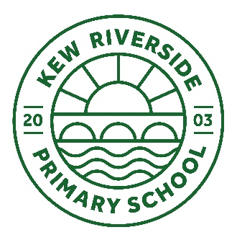

**Parent withdrawal form from Sex Education included in RSHE**

|  |  |  |  |  |
| --- | --- | --- | --- | --- |
| TO BE COMPLETED BY PARENTS | | | | |
| Name of child |  | | Class |  |
| Name of Parent |  | | Date |  |
| Reason for withdrawing from Sex Education as part of Relationships, Sex and Health Education: | | | | |
|  | | | | |
| Any other information you would like the school to consider: | | | | |
|  | | | | |
| Parent signature | |  | | |

|  |  |
| --- | --- |
| TO BE COMPLETED BY SCHOOL | |
| Agreed actions from discussion with parents |  |